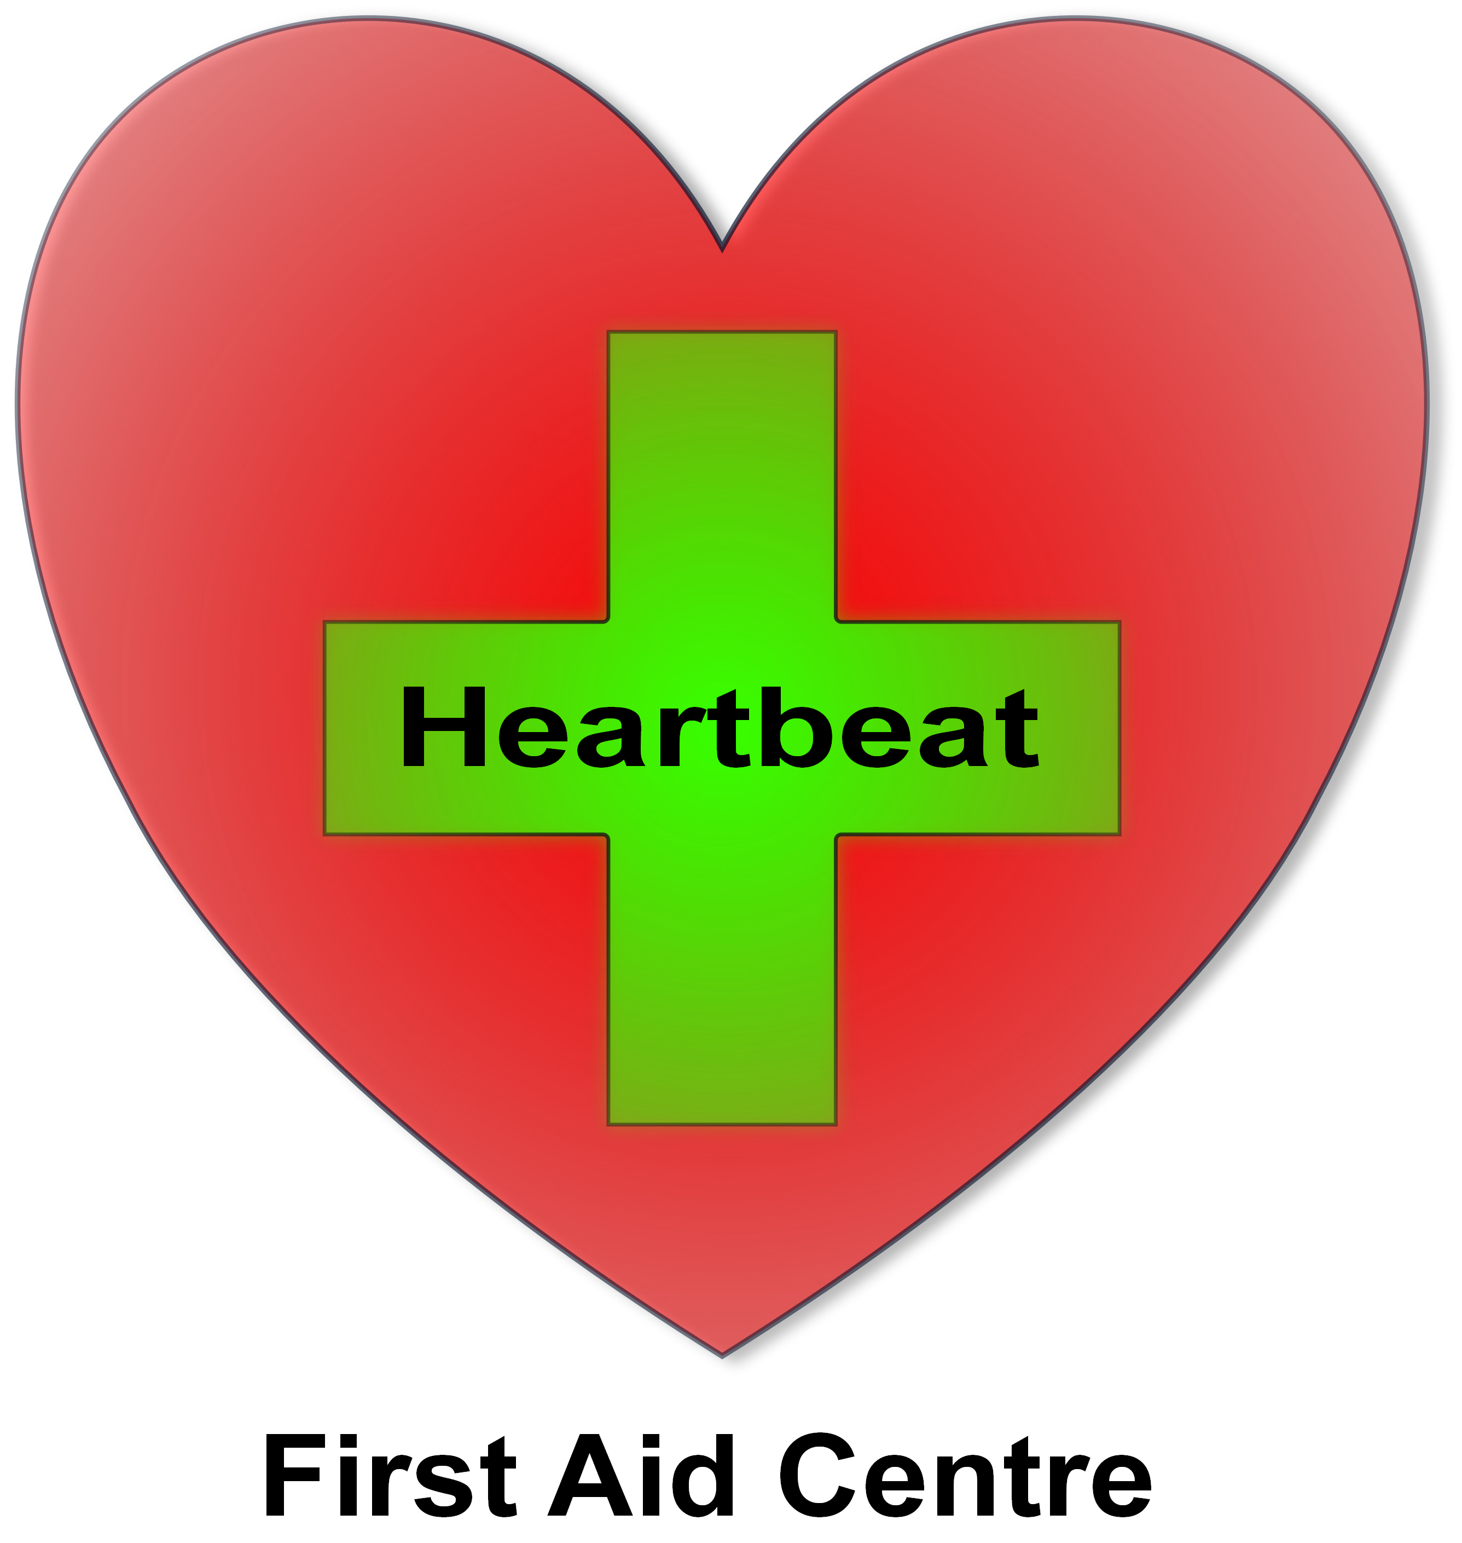

Heartbeat – Course Booking form
To book an Emergency First Response course we require an initial £70 Booking Fee per person, or balance with this booking form stating your start date. Once we have received your booking we will go ahead and book the venue plus staff then we will confirm your course details in full. All the materials, consumables, and certification will be supplied by Heartbeat. Balance is required 4 weeks prior to start date.
Contact Person  Miss/Ms/Mrs/Mr/Dr | First Name: | Surname:
Company Invoice Address:
Post Code:
Work Tel: Mobile:
Company position title:
email:
Date of Birth: / /
Course start date: / / 2019 Course end date: / /
Payment Methods Details: BACS /Cheque +£2
1. BACS – Sort Code 20-25-42 Act No. 70717282
2. Cheque - Payable to C-Life Ltd, add £2 for admin per cheque sent
Please state how you are sending money: BACS/Cheque

Course Choice | Tick √
1) Primary Care (CPR) @£90 - ½ Day
2) Secondary Care (First Aid) @£90 - ½ Day
3) Primary Care (CPR) & Secondary Care (First Aid) @£120 - 1 Day
4) Care for Children Course £110 - 1 Day
5) CPR & AED Course £120 - 1 Day
6) 1 Day Emergency First Aid at Work £140
7) 3 Day First Aid at Work @£295
8) First Aid at Work re-qualification Course @£210 inc
9) 12hr Care for Children for professional care providers £170 - 2 Days
10) Primary Care for Schools £95 - 1 Day
11) Manual Handling £120 - ½ Day
*Add £5 postage or collect
How many participants would you like to book?: | No.
Total sent | £

Terms and Conditions
If weather or any other circumstances beyond the control of C-LIFE/HEARTBEAT causes the course to be delayed, changed or cancelled, no liability can be accepted by the aforesaid party for consequential loss, damage or expense incurred. Candidates using C-LIFE/HEARTBEAT equipment for any course are responsible for that equipment and will be charged for any loss or damage arising from negligent behaviour. C-LIFE/HEARTBEAT or its employees cannot be held responsible for damage, loss or injury caused by negligence or otherwise. There is a 48hr cancellation policy. Candidates will agree to abide by the rules of C-LIFE Ltd/HEARTBEAT in all training matters.

I have read, understood and agreed the terms and conditions of the booking.

Signature Date / /

Heartbeat First Aid Centre (a division of C-Life Ltd), C-Life Ltd, COLLODI, Mead Road, Chislehurst, Kent, BR7 6AD.
Tel: 0208 295 4061. M: 07831 444 903. Email: firstaid@heartbeat-firstaid.co.uk website www.heartbeat-firstaid.co.uk

